Lab Report

Date: May 29th , 2026
Team: E1
Team Members
Last name | First name | Email
Rahman | Md Mahbubur | md-mahbubur.rahman@stud.hshl.de
Sakib | Md Naimur Rahaman | md-naimur-rahaman.sakib@stud.hshl.de
Xu | Yongyu | yongyu.xu@stud.hshl.de
Koluacik | Baris | baris.koluacik@stud.hshl.de

Goal
1.Create the first version of SysML diagrams for your vehicle project (github).
- Create initial design and first code draft in Tinkercad (design+code)

Discussion
- The initial design draft in Tinkercad.
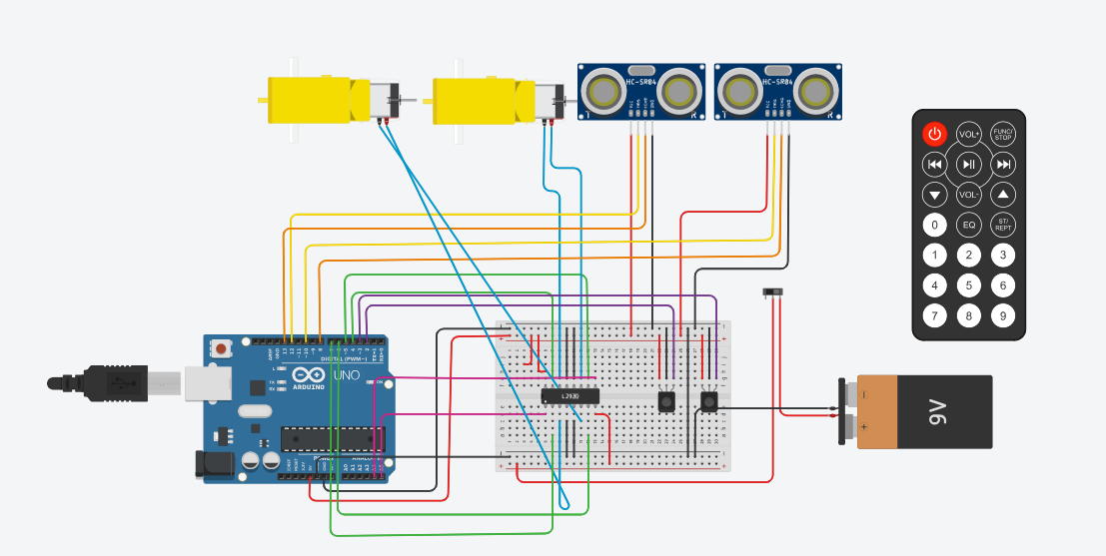
Figure 1 initial design draft in Tinkercad

2.The first code draft in Tinkercad is functioning properly, please refer to the codes in the folder for details.(Folder name : first-codes)
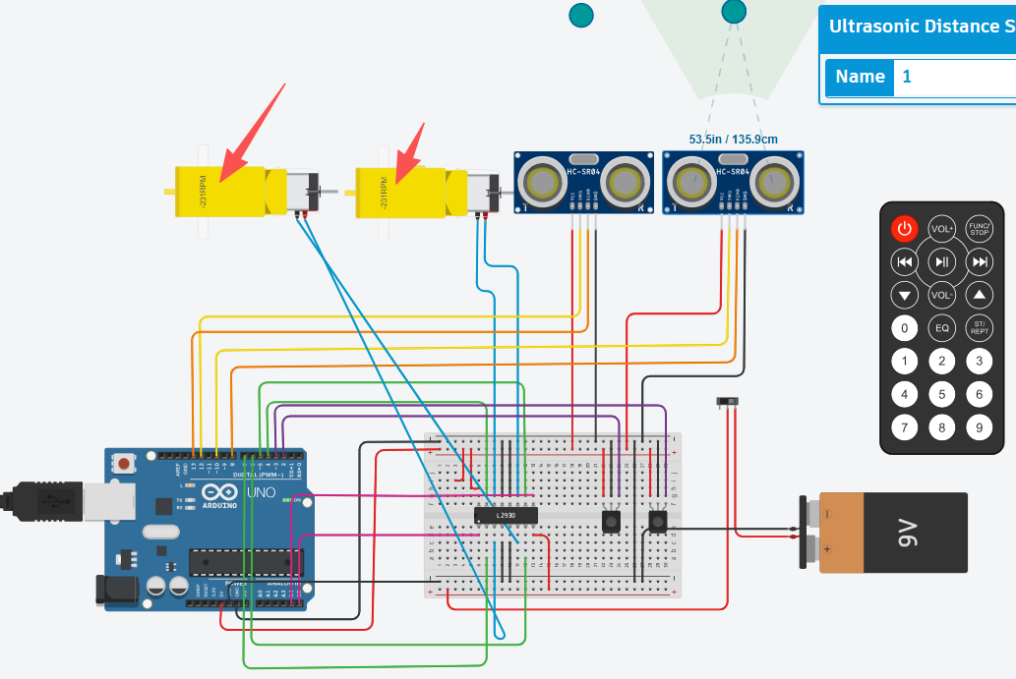
Figure 2 initial design draft in Tinkercad can function properly

3.Sequence Diagram(First Draft)
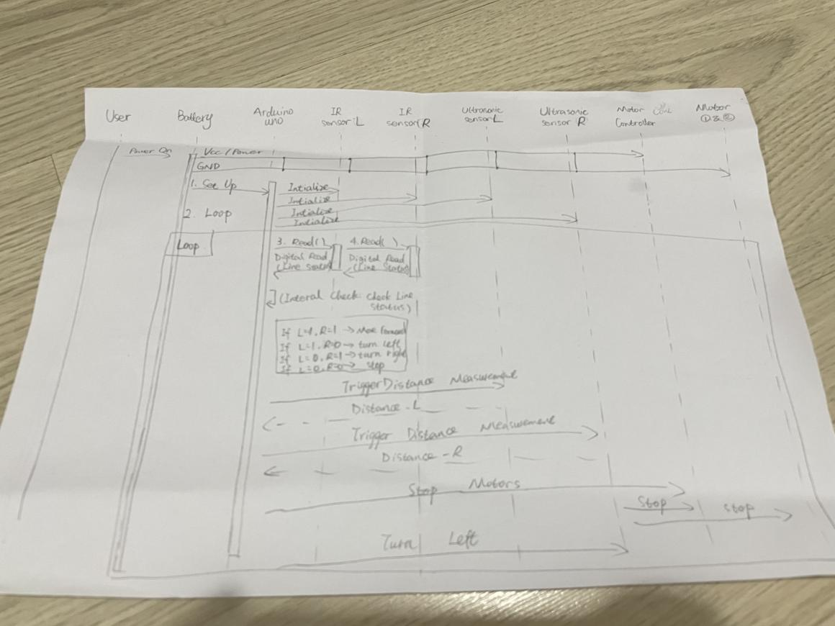

Figure 3 Sequence Diagram(First Draft)

